SERIAL COMMUNICATION

Computers transfer data in two ways: parallel and serial. In parallel data transfers, often 8 or more lines (wire conductors) are used to transfer data to a device that is only a few feet away. Examples of parallel transfers are printers and hard disk; each uses cables with many wire strips. Although in such cases a lot of data can be transferred in a short amount of time by using many wires in parallel, the distance cannot be great. To transfer to a device located at many meters away, the serial method is used. In serial communication, the data is sent one bit at a time, in contrast to parallel communication, in which the data is sent a byte or more at a time.
When a microprocessor communicates with the outside world, it provides the data in byte-sized chunks. In some cases, such as printers, the information is simply grabbed from the 8-bit data bus and presented to the 8-biut data bus of the printer. This can work only if the cable is not too long, since long cables diminish and even distort signals. Furthermore, an 8-bit data path is expensive. For these reasons, serial communication is used for transferring data between two systems located at distances of hundreds of feet to millions of miles apart. The fact that serial communication uses a single data line instead of the 8-bit data line of parallel communication not only makes it much cheaper but also enables two computers located in two different cities to communicate over the telephone.
For serial data communication to work the byte of data must be converted to serial bits using a parallel-in-serial-out shift register; then it can be transmitted over a single data line. This also means that at the receiving end there must be a serial-in-parallel-out shift register to receive the serial data and pack them into a byte. Of course, if data is to be transferred on the telephone line, it must be converted from 0s and 1s to audio tones, which are sinusoidal-shaped signals. This conversion is performed by a peripheral device called a modem, which stands for “modulator/demodulator”.
Serial data communication uses two methods, asynchronous and synchronous. The synchronous method transfers a block of data at a time, while the asynchronous method transfers a single byte at a time. It is possible to write software to use either of these methods, but the programs can be tedious and long. For this reason, there are special IC chips made by many manufacturers for serial data communication. These chips are commonly referred to as UART (Universal Asynchronous Receiver and Transmitter) and USART (Universal Synchronous-Asynchronous Receiver and Transmitter). The 8051 microcontroller has a built-in UART.
RS232 Standards
To allow compatibility among data communication equipment made by various manufacturers, an interfacing standard called RS232 was set by the Electronics Industries Association (EIA) in 1960. Today, RS232 is the most widely used serial I/O interfacing standard. However, since the standard was set long before the advent of TTL logic family, its input and output voltage levels are not TTL compatible. In RS232, a 1 is represented by -3 to -25V, while a 0 bit is +3 to +25V, making -3 to +3 undefined. For this reason, to connect any RS232 to a microcontroller system we must use voltage converters such as MAX232 to convert the TTL logic levels to the RS232 voltage levels, and vice versa. MAX232 IC chips are commonly referred to as line drivers.
RS232 Pins
The following table provides the pins and their labels for the RS232 cable, commonly referred to as the DB-25 connector. In labeling, DB-25P refers to the plug connector (male) and DB-25S is for the socket connector (female).
PIN | DESCRIPTION
1 | Protective ground
2 | Transmitted data (TxD)
3 | Received data (RxD)
4 | Request to send (RTS)
5 | Clear to send (CTS)
6 | Data set ready (DSR)
7 | Signal ground (GND)
8 | Data carrier detect (DCD)
9/10 | Reserved for data testing
11 | Unassigned
12 | Secondary data carrier detect
13 | Secondary clear to send
14 | Secondary transmitted data
15 | Transmit signal element timing
16 | Secondary received data
17 | Receive signal element timing
18 | Unassigned
19 | Secondary request to send
20 | Data terminal ready (DTR)
21 | Signal quality detector
22 | Ring indicator
23 | Data signal rate select
24 | Transmit signal element timing
25 | Unassigned

Since not all the pins are used in PC cables, IBM introduced the DB-9 version of the serial I/O standard, which uses 9 pins only, as shown in the following table:
PIN | DESCRIPTION
1 | Data carrier detect (DCD)
2 | Received data (RxD)
3 | Transmitted data (TxD)
4 | Data terminal ready (DTR)
5 | Signal ground (GND)
6 | Data set ready (DSR)
7 | Request to send (RTS)
8 | Clear to send (CTS)
9 | Ring indicator (RI)

SERIAL COMMUNICATION IN AVR

The Universal Synchronous and Asynchronous serial Receiver and Transmitter (USART) is a highly flexible serial communication device. The main features are:

• Full Duplex Operation (Independent Serial Receive and Transmit Registers)
• Asynchronous or Synchronous Operation
• Master or Slave Clocked Synchronous Operation
• High Resolution Baud Rate Generator
• Supports Serial Frames with 5, 6, 7, 8, or 9 Data Bits and 1 or 2 Stop Bits
• Odd or Even Parity Generation and Parity Check Supported by Hardware
• Data OverRun Detection
• Framing Error Detection
• Noise Filtering Includes False Start Bit Detection and Digital Low Pass Filter
• Three Separate Interrupts on TX Complete, TX Data Register Empty, and RX Complete
• Multi-processor Communication Mode
• Double Speed Asynchronous Communication Mode
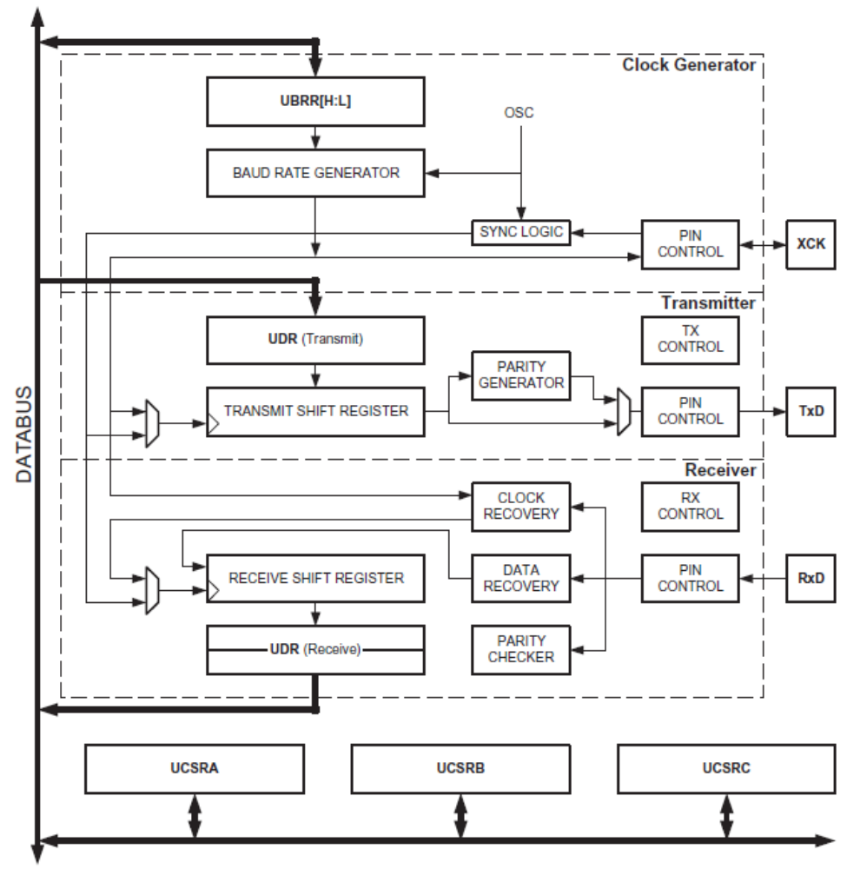
The dashed boxes in the block diagram separate the three main parts of the USART (listed from the top): Clock Generator, Transmitter and Receiver. Control Registers are shared by all units. The clock generation logic consists of synchronization logic for external clock input used by synchronous slave operation, and the baud rate generator. The XCK (Transfer Clock) pin is only used by Synchronous Transfer mode. The Transmitter consists of a single write buffer, a serial Shift Register, parity generator and control logic for handling different serial frame formats. The write buffer allows a continuous transfer of data without any delay between frames. The Receiver is the most complex part of the USART module due to its clock and data recovery
units. The recovery units are used for asynchronous data reception. In addition to the recovery units, the receiver includes a parity checker, control logic, a Shift Register and a two level receive buffer (UDR). The receiver supports the same frame formats as the transmitter, and can
detect frame error, data overrun and parity errors.

AVR USART vs. AVR UART – Compatibility
The USART is fully compatible with the AVR UART regarding:
• Bit locations inside all USART Registers
• Baud Rate Generation
• Transmitter Operation
• Transmit Buffer Functionality
• Receiver Operation
However, the receive buffering has two improvements that will affect the compatibility in some
special cases:
• A second Buffer Register has been added. The two Buffer Registers operate as a circular FIFO buffer. Therefore the UDR must only be read once for each incoming data! More important is the fact that the Error Flags (FE and DOR) and the 9th data bit (RXB8) are buffered with the data in the receive buffer. Therefore the status bits must always be read before the UDR Register is read. Otherwise the error status will be lost since the buffer state is lost.

• The receiver Shift Register can now act as a third buffer level. This is done by allowing the received data to remain in the serial Shift Register if the Buffer Registers are full, until a new start bit is detected. The USART is therefore more resistant to Data OverRun (DOR) error conditions.

The following control bits have changed name, but have same functionality and register location:
• CHR9 is changed to UCSZ2
• OR is changed to DOR
Clock Generation The clock generation logic generates the base clock for the Transmitter and Receiver. The USART supports four modes of clock operation: Normal Asynchronous, Double Speed Asynchronous, Master Synchronous and Slave Synchronous mode. The UMSEL bit in USART Control and Status Register C (UCSRC) selects between asynchronous and synchronous operation.

Double Speed (Asynchronous mode only) is controlled by the U2X found in the UCSRA Register. When using Synchronous mode (UMSEL = 1), the Data Direction Register for the XCK pin (DDR_XCK) controls whether the clock source is internal (Master mode) or external (Slavemode). The XCK pin is only active when using Synchronous mode.

Internal Clock Generation – The Baud Rate Generator

Internal clock generation is used for the asynchronous and the synchronous master modes of operation. The USART Baud Rate Register (UBRR) and the down-counter connected to it function as a programmable prescaler or baud rate generator. The down-counter, running at system clock (fosc), is loaded with the UBRR value each time the counter has counted down to zero or when the UBRRL Register is written. A clock is generated each time the counter reaches zero. This clock is the baud rate generator clock output (= fosc/(UBRR+1)). The Transmitter divides the baud rate generator clock output by 2, 8 or 16 depending on mode. The baud rate generator output is used directly by the receiver’s clock and data recovery units. However, the recovery units use a state machine that uses 2, 8 or 16 states depending on mode set by the state of the UMSEL, U2X and DDR_XCK bits.
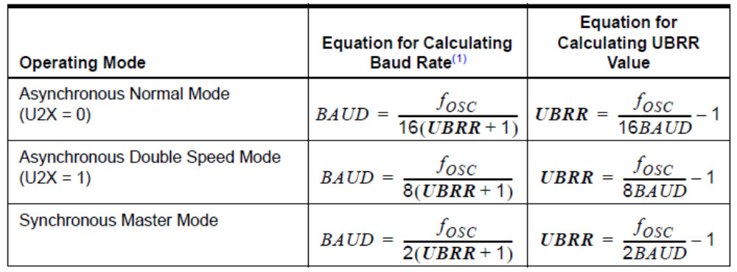
USART Initialization

The USART has to be initialized before any communication can take place. The initialization process normally consists of setting the baud rate, setting frame format and enabling the Transmitter or the Receiver depending on the usage. For interrupt driven USART operation, the Global Interrupt Flag should be cleared (and interrupts globally disabled) when doing the initialization.

Before doing a re-initialization with changed baud rate or frame format, be sure that there are no ongoing transmissions during the period the registers are changed. The TXC Flag can be used to check that the Transmitter has completed all transfers, and the RXC Flag can be used to
check that there are no unread data in the receive buffer. Note that the TXC Flag must be cleared before each transmission (before UDR is written) if it is used for this purpose.

Data Transmission – The USART Transmitter

The USART Transmitter is enabled by setting the Transmit Enable (TXEN) bit in the UCSRB Register. When the Transmitter is enabled, the normal port operation of the TxD pin is overridden by the USART and given the function as the transmitter’s serial output. The baud rate, mode of operation and frame format must be set up once before doing any transmissions. If synchronous operation is used, the clock on the XCK pin will be overridden and used as transmission clock.
Sending Frames with 5 to 8 Data Bit

A data transmission is initiated by loading the transmit buffer with the data to be transmitted. The CPU can load the transmit buffer by writing to the UDR I/O location. The buffered data in the transmit buffer will be moved to the Shift Register when the Shift Register is ready to send a new frame. The Shift Register is loaded with new data if it is in idle state (no ongoing transmission) or immediately after the last stop bit of the previous frame is transmitted. When the Shift Register is loaded with new data, it will transfer one complete frame at the rate given by the Baud Register, U2X bit or by XCK depending on mode of operation.

